DATA WAREHOUSING AND DATA MINING LABORATORY

B.KISHOREKUMAR

18BCS042

1. Download a suitable dataset for association from any Repository. List the attributes and its type in a word Doc..

The Attributes are

Variance – Numeric scaled

Skewness – Numeic scaled

Curtosis – Numeric scaled

Entropy – Binary scaled

1. Implement Python code to apply Apriori algorithm to mine association rules for the given dataset. Use suitable packages and List all the rules with Min_support = 0.6 and Confidence = 0.8 of min_length =2.

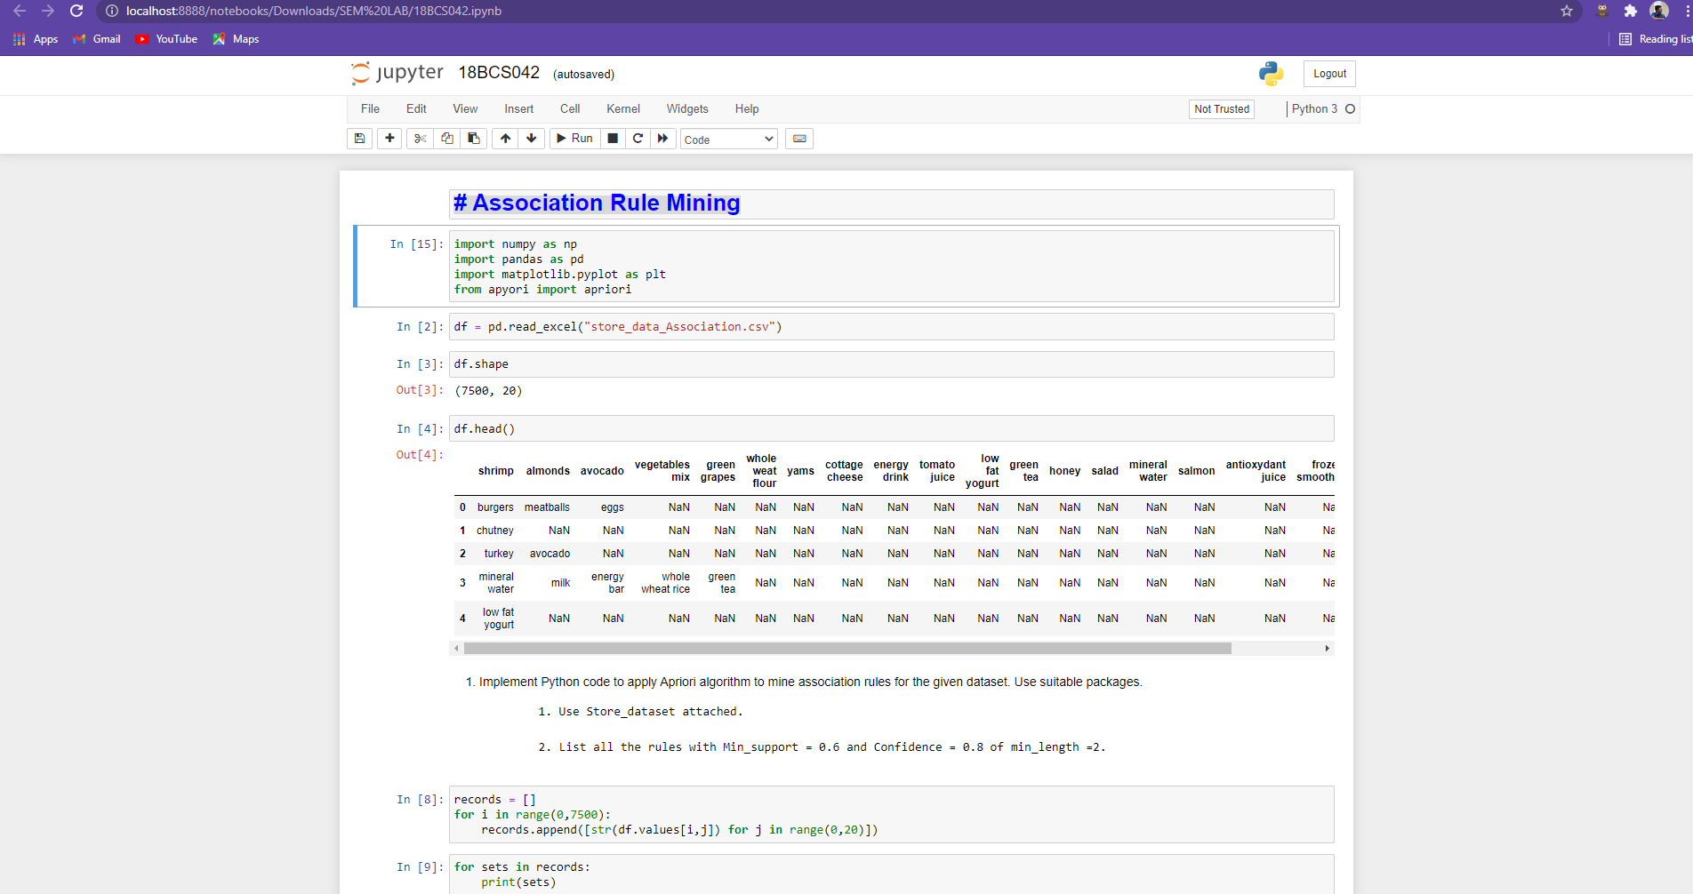

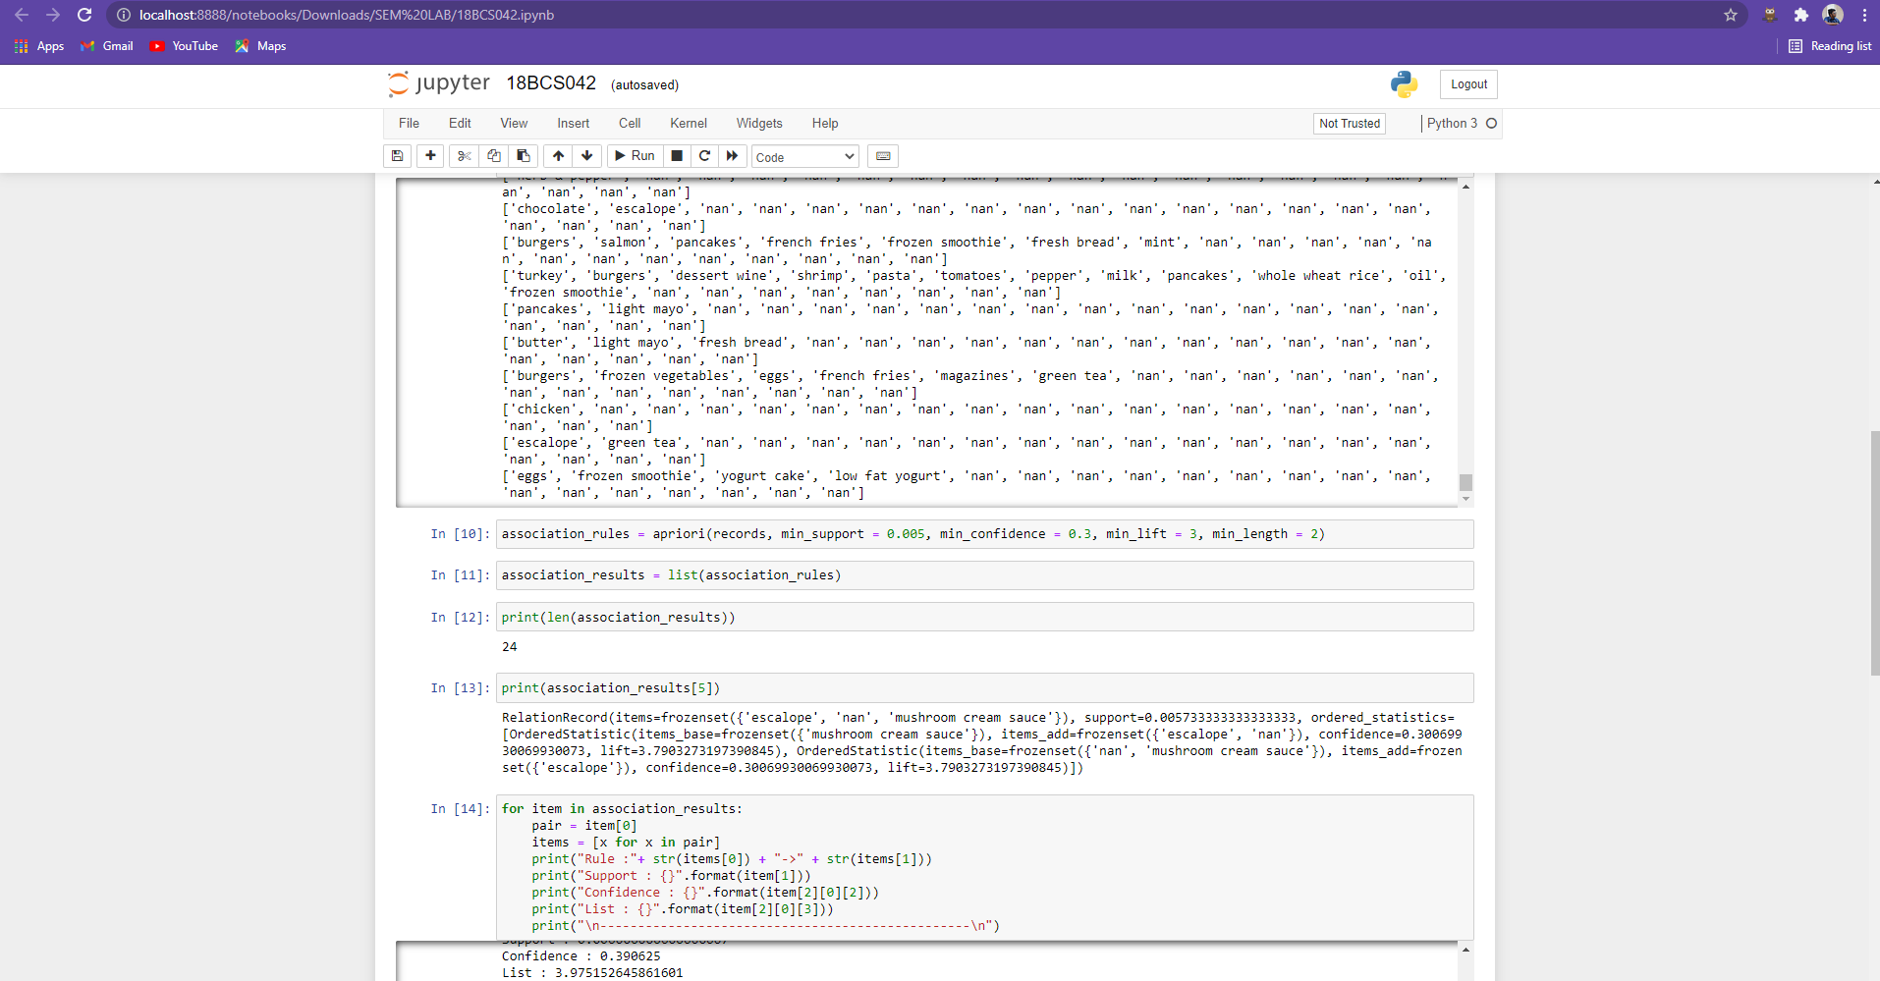

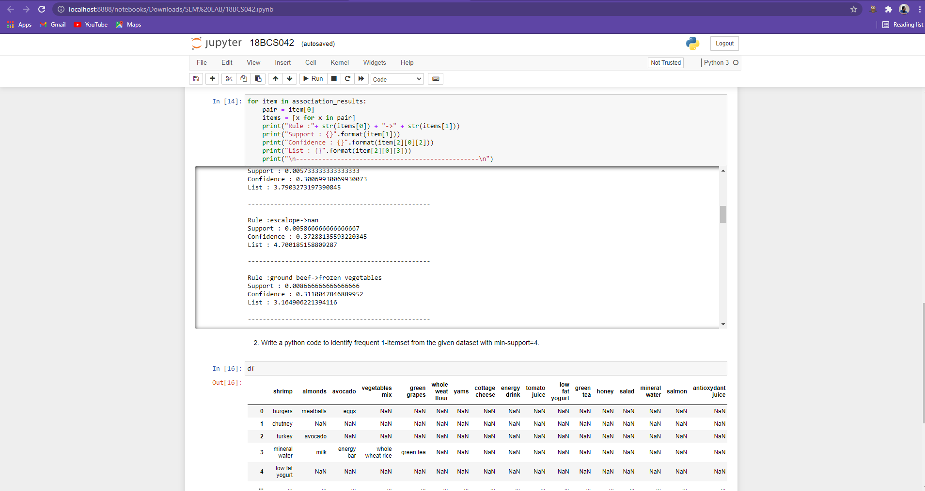

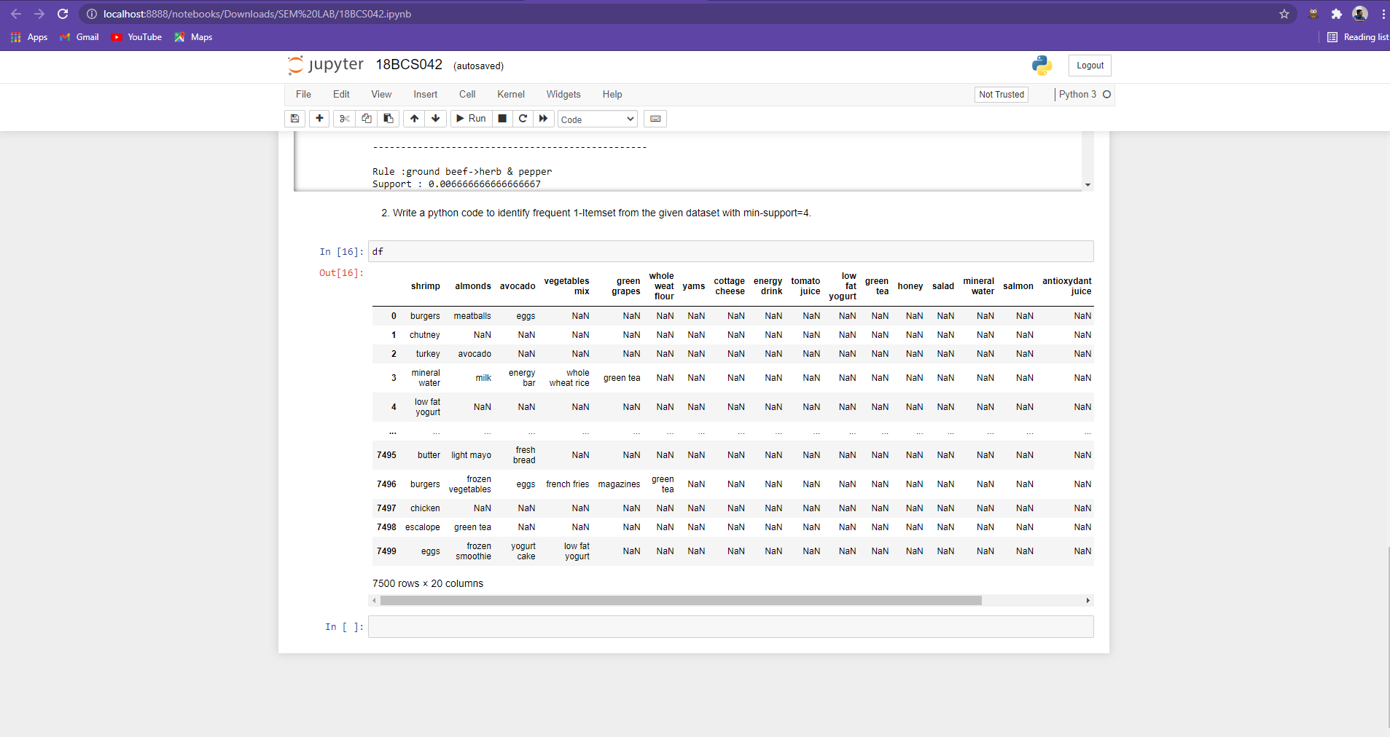

1. GITHUB LINK : https://github.com/Kishore-kumar7/SEMLAB